AWS Web Application Firewall (WAF)

What is AWS WAF?
Amazon Web Services AWS WAF (Web Application Firewall) is a security service used to protect web applications from common web exploits and attacks.
It filters and monitors HTTP/HTTPS traffic between users and your web application.

Why AWS WAF is Used
AWS WAF helps protect applications from:
- SQL Injection (SQLi)
- Cross-Site Scripting (XSS)
- DDoS Layer 7 attacks
- Bot traffic
- IP spoofing
- Malicious requests
- Rate-based attacks

AWS WAF Works With
AWS WAF can be attached to:
- Amazon CloudFront
- Application Load Balancer (ALB)
- Amazon API Gateway
- AWS AppSync
- Amazon Cognito

Components of AWS WAF
1. Web ACL (Access Control List)
A Web ACL is the main container where rules are added.
It decides whether requests are:
- Allow
- Block
- Count
- CAPTCHA / Challenge

2. Rules
Rules inspect web requests.
Types of Rules
- Managed Rules
- Custom Rules
- Rate-based Rules
- IP Set Rules
- Geo Match Rules

3. Rule Groups
Collection of multiple rules.
Example:
- AWS Managed Rule Group
- Custom Security Rule Group

4. IP Sets
Used to allow or block specific IP addresses.
Example:
- Block malicious IPs
- Allow office public IPs

5. Regex Pattern Sets
Used for matching specific patterns in requests.
Example:
- Block special characters
- Detect suspicious URLs

Types of AWS WAF Rules
AWS Managed Rules
Predefined rules maintained by AWS.
Examples:
- Core Rule Set
- SQL Database Protection
- Linux Protection
- PHP Protection
Benefits:
- Easy to deploy
- Automatically updated

Custom Rules
Rules created manually by users.
Example:
- Block requests from a country
- Allow only company IP addresses

Rate-Based Rules
Blocks IPs sending too many requests.
Example:
- More than 1000 requests in 5 minutes
Useful against:
- Brute-force attacks
- HTTP flood attacks

Example Architecture
Users
↓
CloudFront / ALB
↓
AWS WAF
↓
Web Application

How AWS WAF Processes Requests
- User sends request
- WAF checks Web ACL rules
- Rules evaluate request
- Action is taken:
  - Allow
  - Block
  - Count
  - CAPTCHA

Steps to Create AWS WAF
Using AWS Console
- Open AWS Console
- Go to AWS WAF
- Create Web ACL
- Select Resource
  - ALB
  - CloudFront
  - API Gateway
- Add rules
- Set default action
- Review and create

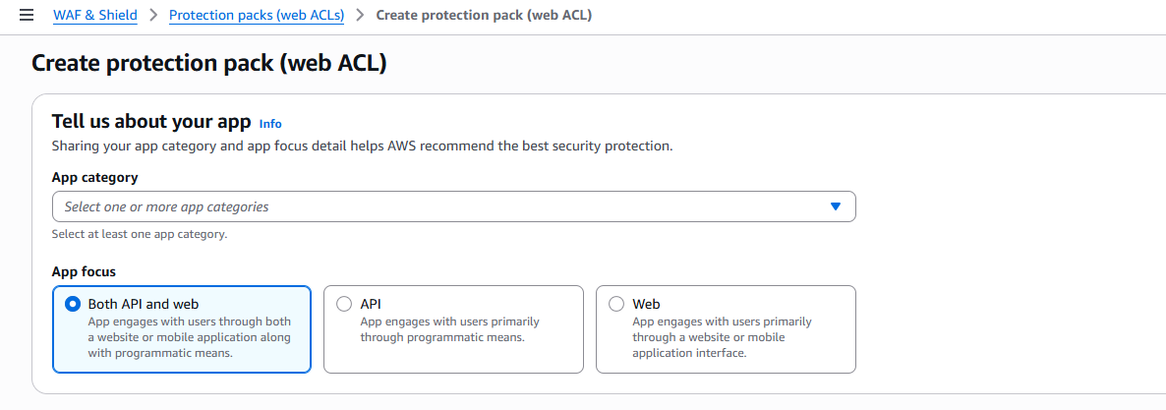

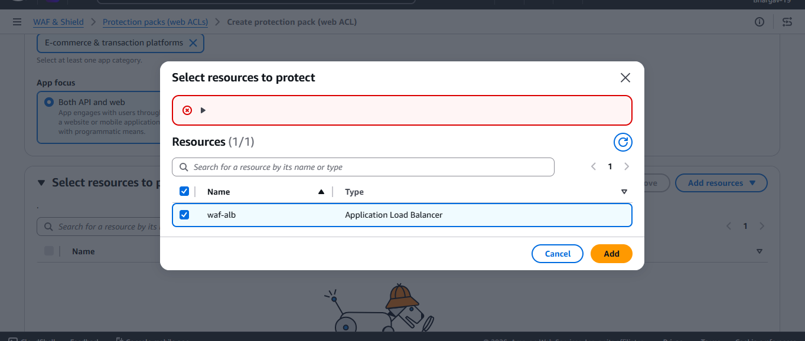

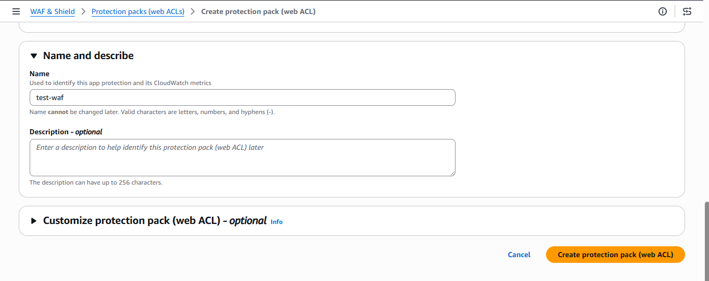

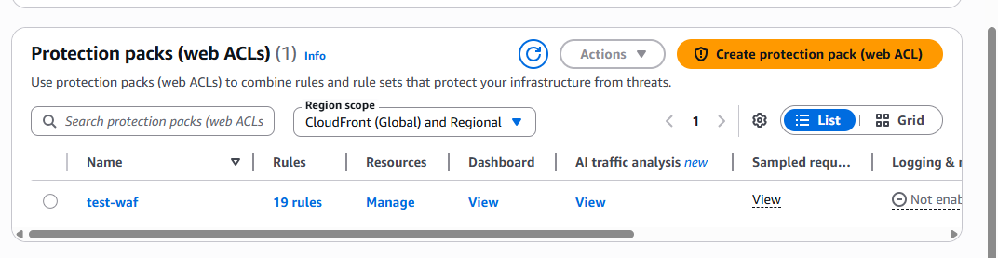

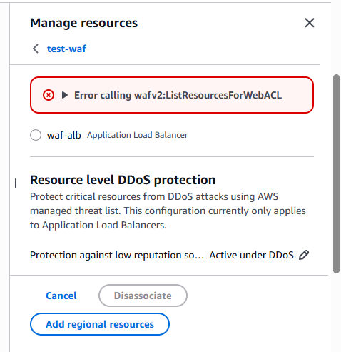

Check with unauthorized DNS
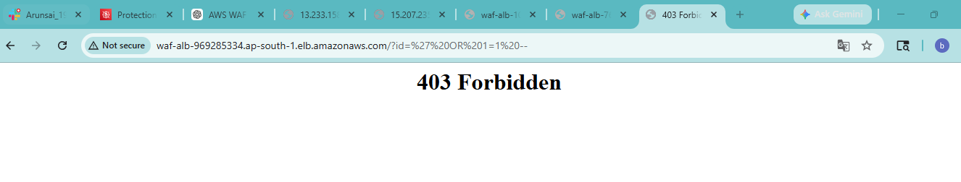
Go to dashboard here we can see the result
